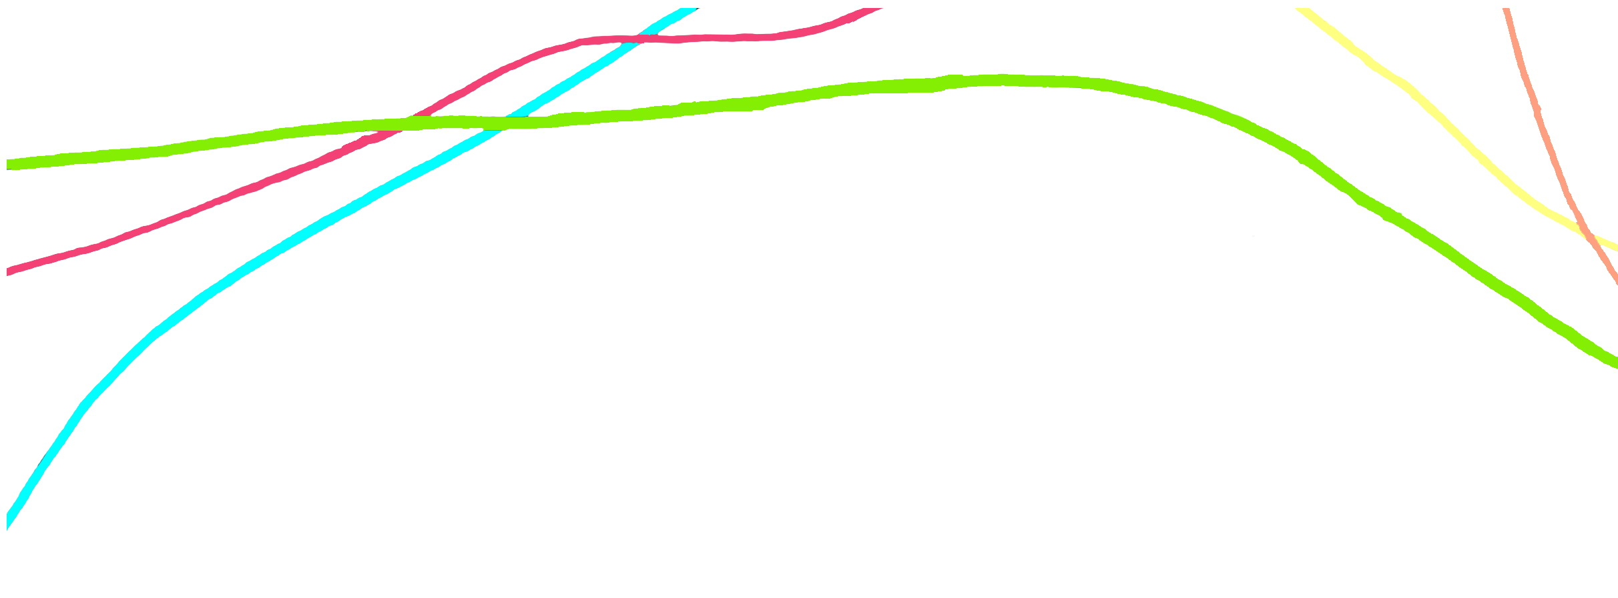
Application form

for participation in the 1st International Artistic and Scientific Conference
Persons with Disabilities in Arts, Science and Education
(The Academy of Arts and Culture in Osijek, 5-6 December 2019)

Deadline for submission: October 15, 2019
Send applications to: konferencija.osi@aukos.hr; konferencija.osi@gmail.com
Name, surname:
Status:
- scientific,
- artistic,
- doctoral,
- disabled person,
- participant without presentation
Address:
E-mail:
Type of participation:
a) presentation
b) examples of good practice for disabled people
c) demonstration workshops
d) posters
Section:
Title of the paper:
Abstract (max. 300 words) and Key words:

