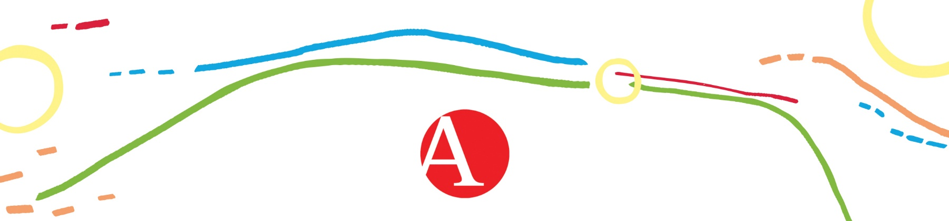
APPLICATION FORM
for participation in the 2nd International Artistic and Scientific Conference
Persons with Disabilities in Arts, Science and Education
(The Academy of Arts and Culture in Osijek, 2–3 December 2021)
Deadline for submission: October 15, 2021
Send applications to: konferencija.osi@aukos.hr; konferencija.osi@gmail.com
Name and surname:
Institution and position held:
Status:
- scientific
- artistic
- doctoral
- disabled person
- participant without presentation
Address:
E-mail and cell phone number:
Type of participation:
- presentation
- examples of good practice for disabled people
- demonstration workshops
- posters
Section:
Title of the paper:
Abstract in Croatian and English
(maks. 300 words)
Keywords:
