JURY MEMBERS 2020.

Berislav Jerković (HR)
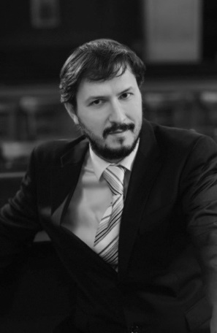
Maria Temesi (HUN)
Violeta Radaković Pančetović (SRB)
Davor Mikulić (SLO)
Martina Zadro (HR)

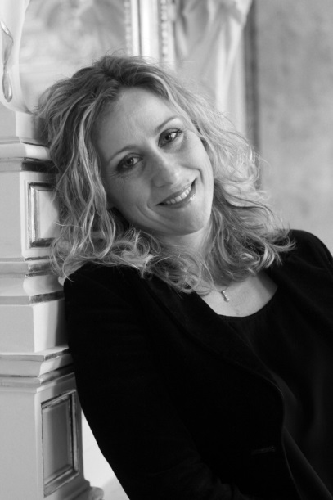

Filip Pavišić (HR)

