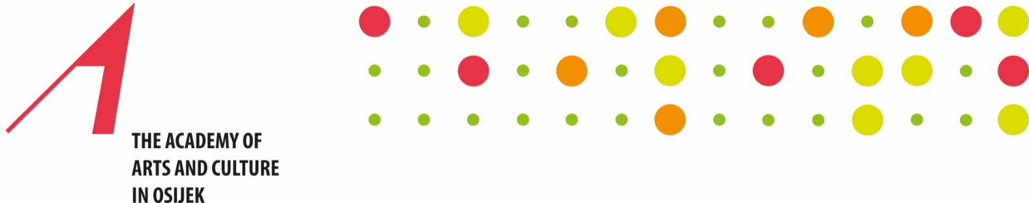

APPLICATION FORM
for the participation in the 3rd International Artistic and Scientific Conference
Persons with Disabilities in Arts, Science and Education
(Academy of Arts and Culture of Osijek, 1–2 December 2023)
Deadline for abstract submission: November 1, 2023
Send applications to: konferencija.osi3@aukos.hr; konferencija.osi3@gmail.com
Name and surname:
Institution and position held:
Status:
- scientific
- artistic
- doctoral
- disabled person
- participant without presentation
Address:
E-mail and cell phone number:
Type of participation:
- presentation
- good practice examples in working with persons with disabilities
- demonstration workshop
- posters
Section:
Title of the paper:
Abstract in Croatian and English
(max. 300 words)
Keywords:

